|  |
| --- |
| **PM-04-PS02:  Develop a project cost estimate** |

Topic elements to be covered include:

1. AK0201 The process dynamics of cost management planning
2. AK0202 Costing metrics, data analysis and reporting

**Resources:**

|  |  |
| --- | --- |
| Knowledge | Information from Project Manager Curriculum |
| National Curriculum Framework | 21905000-KM- 05, Project Cost Management  KM-05-KT01: Plan cost management  KT0101 Project cost management planning concepts and flow of data |

You have been tasked with remodelling a room above the double garage into a man cave / she shed. The room is completely empty with bare walls and a cement flooring. Your first order of business would be to develop a project cost estimate for this project.

You can use the design below or create your own design to work from. You can research pricing for such a project online.

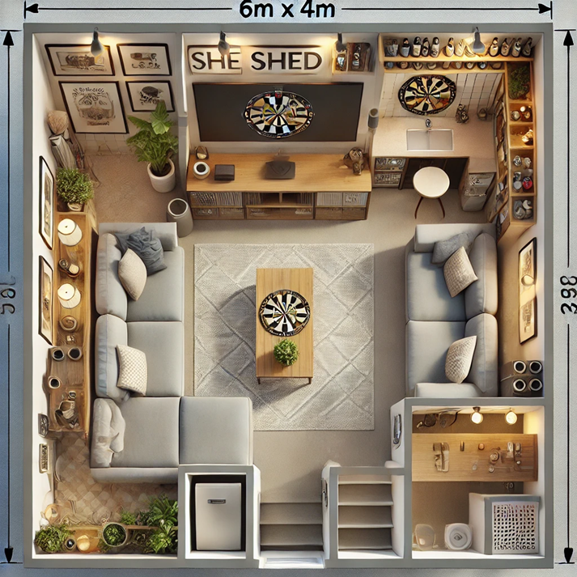

Use the template in the following page to create your project cost estimates.

|  |  |  |  |  |  |
| --- | --- | --- | --- | --- | --- |
| Job Description |  |  |  |  |  |
|  |  |  |  |  |  |
|  |  |  |  |  |  |
|  |  |  |  |  |  |
|  |  |  |  |  |  |
|  |  |  |  |  |  |
| Project Phase | Vendor/Contractor | Labour | Materials | Total | Notes |
|  |  |  |  | R - |  |
|  |  |  |  | R - |  |
|  |  |  |  | R - |  |
|  |  |  |  | R - |  |
|  |  |  |  | R - |  |
|  |  |  |  | R - |  |
|  |  |  |  | R - |  |
|  |  |  |  | R - |  |
|  |  |  |  | R - |  |
| Subtotal |  | R - | R - | R - |  |
| Project Phase | Vendor/Contractor | Labour | Materials | Total | Notes |
|  |  |  |  | R - |  |
|  |  |  |  | R - |  |
|  |  |  |  | R - |  |
|  |  |  |  | R - |  |
|  |  |  |  | R - |  |
|  |  |  |  | R - |  |
|  |  |  |  | R - |  |
|  |  |  |  | R - |  |
|  |  |  |  | R - |  |
| Subtotal |  | R - | R - | R - |  |
| Project Phase | Vendor/Contractor | Labour | Materials | Total | Notes |
|  |  |  |  | R - |  |
|  |  |  |  | R - |  |
|  |  |  |  | R - |  |
|  |  |  |  | R - |  |
|  |  |  |  | R - |  |
|  |  |  |  | R - |  |
|  |  |  |  | R - |  |
|  |  |  |  | R - |  |
|  |  |  |  | R - |  |
| Subtotal |  |  |  | R - |  |
| Grand Total |  | R - | R - | R - |  |

**Observation Checklist**

**Check that the following is accomplished:**

|  |  |  |  |  |
| --- | --- | --- | --- | --- |
| **Item** | | **Checked (Yes=5**  **No=0)** | **Comment: where did you find the evidence?** | |
| IAC0201 Cost estimates accurately reflects the costs of planned project activities included in the WBS | |  |  | |
| IAC0202 Estimates are based on an interpretation and evaluation of cost alternatives | |  |  | |
| IAC0203 Risks and contingencies are accounted for in cost estimates | |  |  | |
| **Name of member** |  | | | |
| **Signature** |  | | | |
| **Date** |  | | | |
| **Total** | | | | **/15** |

|  |  |  |  |
| --- | --- | --- | --- |
| **Facilitator signature** |  | **Date** |  |